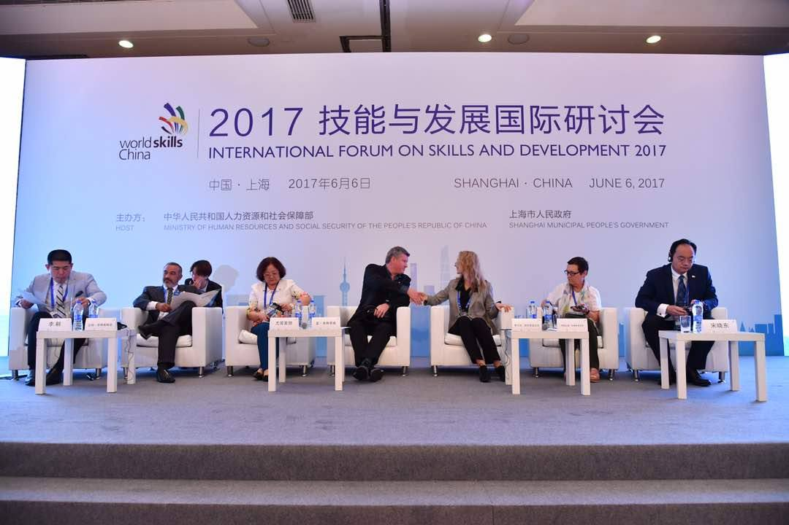

International forum on skills and development 2017.

Important event.